English
18V
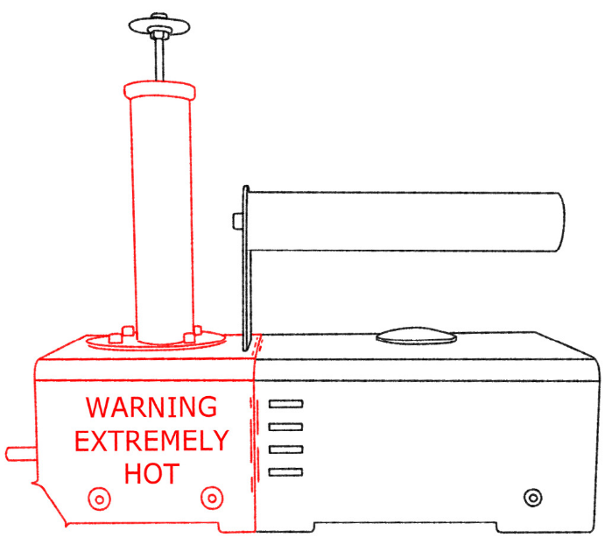
User’s Manual for InstantVap 18V Cordless Oxalic Acid Vaporizer
WARNING
EXTREMELY HOT
← Dispenser tube

Always wear proper safety gear:
- Thick gloves
- Respirator (full face mask with ABE1P3 or ABE2P3 combined filter inserts)
- Safety glasses in case the mask is not full face
- Long sleeves
- For outdoor use only!

Unit retains heat for long after use!
Do not rest device on flammable materials like grass or straw. Transport only when cooled.

Current temp. →
Set temp. →
Switch on/off
↓
↑ ↑
Changing set temp.
How to use the InstantVap 18V

1. Connect your battery
- Make sure power switch is OFF to start
- Unit should read current temperature but not heat up

2. Let it boot and after 3-5 seconds you may flip the switch to power on the heater

3. Before treating check your voltage
- Monitoring battery voltage is important to prolong the lifetime of your battery. Never run a battery below 15V. The device switches off at ~ 15,4V due to an inbuilt deep discharge protection circuit, and only starts up if a charged battery is connected. The battery has to be above 17,2V for the device to start up.
4. Wait to treat
- Allow the unit to reach the set temperature (SV) before first treatment. Recommended set temperature is 230℃ (pre-set).
- Press dispenser into oxalic acid to collect dose, then place it into vaporizer and depress dispenser.
- Wait until the current temperature (PV) gets a few degrees near to the set temperature and you can proceed to the next hive.
4. Finishing treatment
- Switch off the unit and allow it to cool down. Remove the battery, never leave it in the unit after use. Do not let your batteries sit around discharged for long, charge them the same day. Clean the vaporizer as described in “Maintenance.”

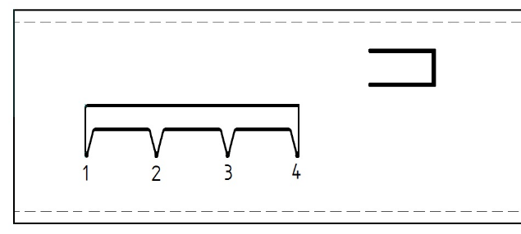
How to adjust the dispenser’s dosage

1. Remove dispenser from vaporizer.
Note: Dispenser gets HOT, use caution!
2. Locate indicator on tube
- Indicator is a hole shaped like the image to the right.
1 = 1gram of oxalic-acid-dehydrate
2. Adjust dosage by twisting the handle
- Do not twist past indicator. Can be set from 1-4g.

Maintenance

Clean the device after a day of treatment.
1. Allow the device to cool to ~80℃. With the battery connected and the switch off, you can monitor the current temperature of the unit.
- A hot device can cause steam that will cause burns. Always be careful!
- In case you use the special silicone cap for cleaning, please use the instructions provided with that.
2. Once cool, rinse the bowl with water via the dispenser tube.
- DO NOT use a lot of water and do not get the water on the rest of the unit, never around the tube where the dispenser fits! Water damage of any kind does not fall under the warranty.
3. After draining the bowl, it is suggested to heat the unit to remove any standing water.
4. Rinse/scrub the dispenser in a bucket of water to remove any residue.
- Add a drop of mineral oil / grease to the O-ring to increase lifespan and ease of use.

From time to time, it is recommended to add a small amount of water (~20 ml) through the dispenser tube into the cooled device, then reinsert the dispenser and heat the device, boiling the water inside. This will clean the bowl more thoroughly. The temperature will not rise above ~110 ℃ until all the water has evaporated from the bowl.

Warranty

We provide 2-year warranty for our unit. In case of any failure, please contact us at the contact info below.

More information and tips about InstantVap and oxalic acid vaporization are available at:
www.instantvap.eu

Contact
Contact name: János Fenyősy
Phone: +36 30 357 3509 (English only)
Email: info@instantvap.hu (any languages)
Company: InstantVap Tech Kft. (CRN: 01-09-411646, Tax nr.: HU27783210)

